# City of Tonawanda Downtown Revitalization Initiative

# Local Planning Committee Meeting #3 Summary

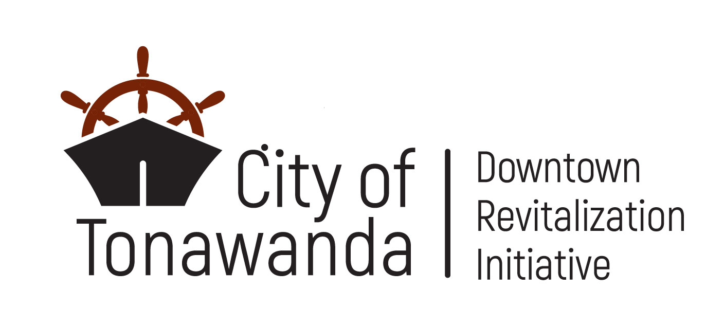July 25, 2024 @ 6:00 – *7:30 pm* | Tonawanda Senior Citizens Center  
35 Main Street, Tonawanda

## Attendees

|  |  |
| --- | --- |
| State Partners  Ben Bidell, NYS Department of State  Angela Keppel, NYS Department of State  Amanda Bearcroft, NYS Department of State  Lenny Skrill, NYS Homes and Community Renewal  Mo Sumbundu, Governor’s Office  Erin Corraro, Empire State Development  City of Tonawanda  Sharon Stuart, City of Tonawanda  Judy Kurtzworth, City of Tonawanda | Local Planning Committee  Co-chair Hon. John White, Mayor  Co-chair Paul Brown, WNY Regional Economic Development Council  Marty Grunzweig  Skip Johnson  Nhi Kha  Debbie Jaeger  Alice Roth  Joan Horn  Jeffrey Ross  Mark Saltarelli  Michelle Lockett  Suzanne Zuchlewski  Consultant Team  WSP  Highland Planning  Prospect Hill |

## Meeting Summary

**Welcome and Introductions**

* LPC Co-Chair Mayor White called the meeting to order and led the pledge of allegiance.
* Mayor White then provided opening remarks and welcomed the LPC.
* LPC Co-Chair Paul Brown (WNY REDC) recited the Code of Conduct preamble. The preamble reminds LPC members of their obligation to act in the public interest and to recuse themselves, if necessary, from talking or making decisions about projects where they have a conflict. The following conflicts are documented:
  + Alice Roth
    - Affiliation: Volunteer and Trustee for Historical Society of the Tonawandas,
    - Project: Long Homestead and Historical Museum Improvements
    - Affiliation: Member of the Twin Cities Elk’s Lodge
    - Project: Renovate 2nd Floor of Elks Lodge into an Event Space
  + Skip Johnson
    - Affiliation: Member and Treasurer of the Historical Society of the Tonawandas
    - Project: Long Homestead and Historical Museum Improvements
  + Mark Saltarelli
    - Affiliation: Member of the Twin Cities Elk’s Lodge
    - Project: Renovate 2nd Floor of Elks Lodge into an Event Space

* Please note the presentation from LPC Meeting #3 is available at [www.TonawandaDRI.com](http://www.TonawandaDRI.com).

**DRI Planning Process and Schedule**

* Stephanie Camay (WSP) summarized the Tonawanda DRI scope and schedule.
* Stephanie provided a recap of LPC Meeting #2, the agenda for LPC Meeting #3, and what to expect at LPC Meeting #4
* Stephanie provided an overview of upcoming DRI milestones and events, which are detailed in the sections below.

**Engagement Updates**

* Stephanie described the engagement activities that occurred since LPC Meeting #2, which included promoting the public survey and Open Call for Projects.
* The public survey deadline was extended to August 2nd
  + A total of 265 responses were received to-date.
  + Initial responses indicate the following priorities for downtown Tonawanda: Supporting and growing businesses, developing underutilized and vacant sites, beautifying Main Street and other streetscapes, and attracting tourism and visitors year-round.
  + Respondents would like to see restaurants, retail, coffee shops, bakeries, and breweries/wineries/distilleries in the downtown area.

**Initial Findings of the Downtown Profile and Assessment**

* Stephanie presented preliminary findings of the Downtown Profile and Assessment, a substantial piece of the final Strategic Investment Plan.
* Some key initial findings include:
  + The DRI area has higher incomes than the New York State median but 12.3% of DRI residents live in poverty, highlighting income inequality in the DRI area.
  + Only about 1% of residents that live in the DRI area work there, meaning most downtown workers commute into Tonawanda, while most downtown residents leave Tonawanda for work.
  + The downtown area is characterized by abundant and underutilized parking spaces – approximately 43% of the downtown area is classified as vacant or parking.
  + Approximately 60% of the downtown area is zoned for exclusively commercial uses, but could change following the City’s planned zoning code update.
  + Despite being a waterfront city, Tonawanda has a very low flood risk.
  + Access to waterways and the waterfront offer significant potential for downtown revitalization, and adoption of the City’s Local Waterfront Revitalization program will boost revitalization efforts.
  + Tonawanda has a rich history and historical assets that could be highlighted and protected through creation of the proposed Tonawanda Main Street Historic District as well as through zoning updates.
* Mayor White commented that zoning changes will support implementation of DRI projects and are planned to be completed in the coming months.

**Vision, Goals, and Strategies**

* Brendan Kelly (WSP) presented the Tonawanda DRI vision statement and goals, which the LPC confirmed as final.
* Brendan presented draft DRI strategies for each of the eight goals, which were edited based on LPC feedback prior to the meeting. The LPC reviewed the updated strategies.
* The LPC confirmed the strategies as final by consensus.

**Project Form Submissions**

* Bob Gibson (WSP) presented an overview of projects submitted during the Open Call for Projects, which was open between May 30th and July 12th.
  + During the Open Call, 21 projects were submitted, comprising a total of $23,000,000 in DRI funding requests towards $91,000,000 in total project costs.
  + Of the submitted projects, six are public improvement projects, three are new development projects, 12 are redevelopment or renovation of existing building projects, and two expressed interest in the Small Project Fund.
* Bob shared a map of project locations. Three submitted projects are outside of the DRI area:
  + Renovate Tonawanda Castle to Reignite Event Center and Introduce Commercial Spaces
  + Renovate 176 Main Street as Two Commercial Units
  + Convert Kohler Pool to Splash Pad and Improve Building
* Bob presented one slide for each project submitted during the Open Call for Projects. The slides contained the following information:
  + Name of Business/Applicant
  + Project Type
  + Project Description
  + Project Location
* LPC Members expressed concern over the “Enhance Main Street Streetscapes” project, citing traffic flow, construction disruptions, and lack of urgent need as primary concerns. An LPC member suggested that the project could be scaled down to incorporate wayfinding on Main Street.
* An LPC member expressed concern that the “Improve Niagara Street Corridor between City Hall and Main Street” would create traffic issues in the city.
* An LPC member reinforced the importance of including wayfinding signing with a cohesive design in the “Enhance the Main Street-Waterfront Connection” project.
* An LPC member expressed concern about injuries over the “Build Nature Playground behind Long Homestead” project.
* LPC Members expressed disapproval over the “Build Guest House at 62 Niagara Shore Drive” project, citing concerns that it would not be a transformational project for the DRI area or fit in with the neighborhood.
* Bob presented an overview of the Small Project Fund and projects to potentially be recommended for the fund, which include:
  + Fiorella’s Garden Center
  + Mike Barry Motors

**Project Discussion**

* Following the presentation of submitted projects, Stephanie led the LPC through initial decision-making on projects, which was achieved through consensus by the LPC.
* The LPC decided to establish the Small Project Fund, pending documentation of interest by local businesses.
* The LPC decided to expand the DRI Boundary to include only “Renovate Tonawanda Castle to Reignite Event Center and Introduce Commercial Spaces.” The following projects were not included in the boundary modification:
* Convert Kohler Pool to Splash Pad and Improve Building, as the project is too far outside the DRI Area.
* Renovate 176 Main Street as Two Commercial Units, as the project is not transformational.
* The following projects were recommended to be removed from the preliminary slate of projects, but recommended for other funding:
  + Convert Kohler Pool to Splash Pad and Improve Building, as the project is outside of the DRI Area.
  + Improve Niagara Street Corridor between City Hall and Main Street, as the project needs further study.
* The following projects were recommended to be removed from the preliminary slate of projects altogether:
  + Enhance Main Street Streetscapes, as the project is not a priority and will disrupt business.
  + Build Tiny Guest House at 62 Niagara Shore Drive, as the project is not transformational.

**Project Evaluation Process**

* Stephanie discussed how LPC evaluations, consultant evaluations, and public feedback will be used by the LPC to develop the final slate of projects recommended for DRI funding.
* During LPC Meeting #4, LPC members will hear brief presentations from project sponsors.
* Between LPC Meeting #4 and #5, LPC members will individually evaluate projects.
* At LPC Meeting #5, LPC members will begin finalizing the slate of projects to recommend for funding.

**Next Steps**

* Stephanie presented an overview of upcoming community engagement opportunities, including:
  + The Public Survey, which closes August 2nd.
  + The Project Feedback Form, which will open in early August.
  + National Night Out pop-up event, which will be held on August 6th.
  + Public Workshop #2, which will be held on August 15th from 5-8PM at the Elks Lodge.

**Public Comment**

* Members of the public made the following comments in conversation with the LPC, State partners, and consultant team:
  + One member of the public sought answers to why the pedestrian bridge needed replacement
    - Mayor White explained that the bridge is in disrepair and fixes are getting expensive. Mayor White also noted that the bridge will be replaced in accordance with NYS Historic Preservation Office guidelines.
  + Audio and visual components of LPC meetings should be amplified/enlarged.
  + LPC should be attuned to business hours when selecting projects to move forward – businesses with shorter hours are less likely to be transformational.
  + Parking lots are almost always empty and should be filled with alternative uses.
  + The project sponsor for “Build Tiny Guest House at 62 Niagara Shore Drive” expressed displeasure about the characterization of his project and its removal from funding consideration.