City of Tonawanda
Downtown Revitalization Initiative

Local Planning Committee Meeting #2 Summary
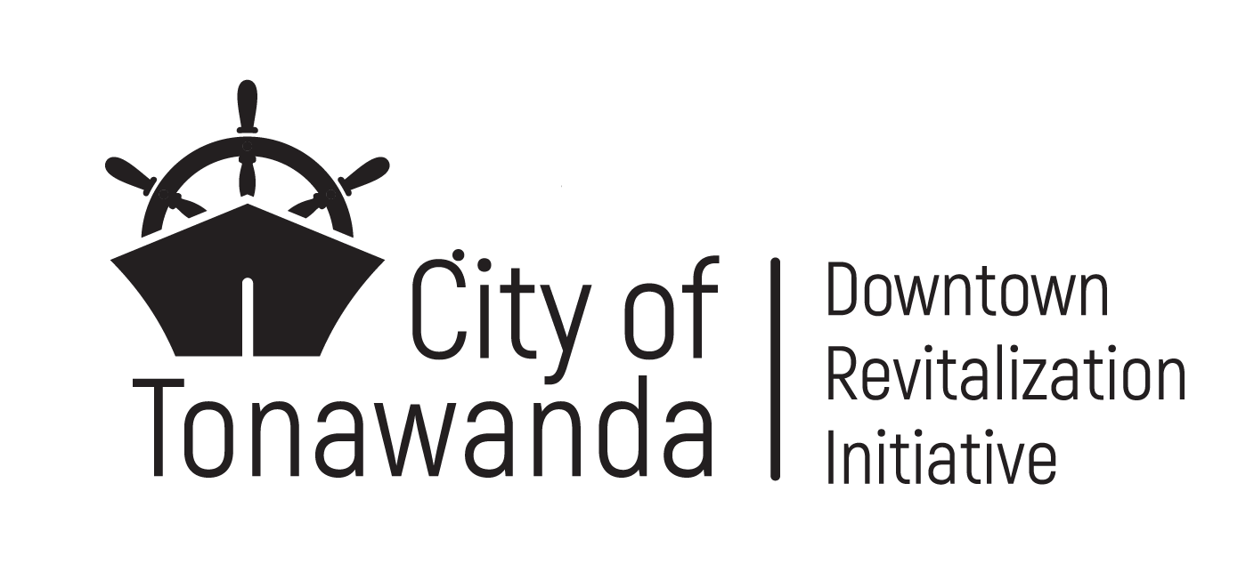
May 29, 2024 @ 6:00 – 7:30 pm | Tonawanda Senior Citizens Center
35 Main Street, Tonawanda

Attendees
State Partners  ☒Ben Bidell, NYS Department of State  ☐Angela Keppel, NYS Department of State  ☐Lenny Skrill, NYS Homes and Community Renewal  ☒Mo Sumbundu, Empire State Development  ☒Erin Corraro, Empire State Development (Virtual)  City of Tonawanda  ☒Sharon Stuart, City of Tonawanda  ☐Judy Kurtzworth, City of Tonawanda | Local Planning Committee  ☒Co-chair Hon. John White, Mayor  ☒Co-chair Paul Brown, WNY Regional Economic Development Council  ☒ Marty Grunzweig  ☐Skip Johnson  ☒Nhi Kha  ☒Debbie Jaeger  ☐Alice Roth  ☒Joan Horn  ☒Jeffrey Ross  ☐Mark Saltarelli  ☐Bob O’Brocta  ☒Michelle Lockett  ☒Suzanne Zuchlewski  Consultant Team  ☒WSP  ☐Highland Planning  ☐Prospect Hill

Meeting Summary
Welcome and Introductions
- Stephanie Camay (WSP) facilitated welcome and introductions.
- LPC Co-Chair Mayor White welcomed LPC members and thanked the public in attendance.
- LPC Co-Chair Paul Brown (WNY REDC) recited the Code of Conduct preamble. The preamble reminds LPC members of their obligation to act in the public interest and to recuse themselves if necessary from talking or making decisions about projects where they have a conflict. The following conflicts are documented:
  - Alice Roth
    - Affiliation: volunteer and trustee on Historical Society of the Tonawandas,
    - Project: Long Homestead and Historical Museum Improvements
  - Skip Johnson
    - Affiliation: member and treasurer of the Historical Society of the Tonawandas
    - Project: Long Homestead and Historical Museum Improvements
DRI Planning Process and Schedule
- Stephanie Camay (WSP) summarized the Tonawanda DRI scope and schedule.
- Stephanie provided an overview of upcoming DRI milestones and events, which include:
  - Open Call for Projects begins May 30th and runs until July 12th.
  - Information sessions on the Open Call for Projects will be held on May 30th at 5:30pm and 6:30pm at the City Hall Community Room. A virtual information session will be held on June 5th.
  - LPC Meeting #3 will be held on July 25th.
Engagement Updates
- Stephanie described the engagement activities that occurred since the first LPC meeting.
- Three engagement events took place on May 16: an event at the Senior Citizens Center in the morning, a student event at the Tonawanda High School in the afternoon, and the DRI Public Workshop #1 in the evening.
  - Senior citizens were primarily concerned with safety, mobility, and quality of life issues in the DRI area.
  - Tonawanda High School students focused on the need for community gathering spaces for teens.
  - Tonawanda residents participated in Public Workshop #1 and shared their vision for the town individually and in groups.
- Stephanie shared the status of public survey, which will be open until July 19 online at TonawandaDRI.com and with paper copies and drop-off boxes available at City Hall, the City of Tonawanda Public Library, Tops on Niagara Street, and the Senior Citizens Center.
Summary of Past Plans and Recent Investments
- Katie O’Sullivan (WSP) presented a summary of past planning efforts in the City of Tonawanda that occurred over the last seven years.
- The following comment was made verbally by a member of the LPC in response to past planning efforts:
  - There should be separation between the bike and pedestrian trail, especially through Niawanda Park. The trail does not feel safe for pedestrians.
- Ben Bidell (DOS) commended the city for its previous planning efforts.
- Mayor White commented that zoning changes will support implementation of DRI projects and are planned to be completed in the next few months.
Characteristics of Strong DRI Projects and Project Slates
- Katie presented key characteristics for strong DRI projects to be included in the final slate of projects, and characteristics of a strong slate or group of DRI projects that the LPC recommends in the Strategic Investment Plan.
- Projects should be well-defined have a capable sponsor, have clear community and economic benefits, have strong public support, be ready to implement, and transform the downtown area.
- The final slate of projects should include $12 to $15 million in DRI funding requests, consist of projects that will revitalize the community, and include a mix of public, private, and nonprofit projects.
- The following comments and clarifications were made by members of the LPC:
  - The LPC is responsible for making sure that all the projects submitted to the State for funding are projects that benefit the community.
  - All DRI projects are submitted by the LPC at once. Several state government agencies decide on which projects get funded (Department of State, Homes and Community Renewal, Empire State Development). The Governor’s office makes the final decision on which projects are funded.
- Katie explained that the Strategic Investment Plan includes a section at the end identifying projects that are community priorities but are not a good fit for the DRI program. These projects are recommended for implementation with other funding sources in the future.

DRI Evaluation Criteria
- Katie shared the State Evaluation Criteria for DRI projects. These include alignment with local and state goals, catalytic effect, project readiness, eligible project type, cost effectiveness, and co-benefits to the community.
- Katie explained that the LPC selects local evaluation criteria that are most relevant to Tonawanda to complement the state criteria. A list of potential local evaluation criteria was shared with the LPC prior to the meeting for feedback. Katie shared the local evaluation criteria that received the most votes by members of the LPC. The six criteria selected were:
  - Transformative potential
  - Ability to provide a sustainable impact to downtown
  - Capacity to implement the project
  - Community and economic benefits
  - Alignment with community vision, goals, and strategies
  - Impact on tax revenue
- The LPC approved the six local evaluation criteria by consensus. The local evaluation criteria will be included in the DRI Project Form and will be used by the LPC to evaluate proposed projects later in the DRI process.
DRI Vision and Goals
- Brendan Kelly (WSP) discussed how the feedback from LPC Meeting #1 on April 30 and the public engagement events on May 16 influenced the development of the recommended DRI vision statement, which is as follows:
  - Downtown Tonawanda will become a commercial and cultural hub at the confluence of the Erie Canal, Niagara River, and Ellicott Creek, offering a distinct blend of historical charm and modern vitality for residents, workers, and visitors of all ages. By capitalizing on its natural and built assets as a waterfront community, downtown Tonawanda will be sustainable; a vibrant place to live, work, gather, and recreate; and a unique regional destination to connect with history, nature, and each other.
- The LPC approved the recommended DRI vision statement by consensus.
- Brendan shared public feedback on strategies and project ideas that influenced the recommended DRI goals. Public feedback focused on embracing the waterfront, nature, walkability, community programming, and local business.
  - The LPC discussed the importance of having overnight accommodations in downtown Tonawanda.
- Brendan shared the Recommended DRI goals based on feedback from the public survey:
  - Attract new shops, restaurants, and other businesses to the downtown area.
  - Make downtown Tonawanda a year-round destination for residents and visitors.
  - Embrace Tonawanda’s waterfront, parks, and trails as key activity centers for residents and visitors alike.
  - Improve walkability throughout downtown and better connect downtown to parks, trails, and neighborhoods.
  - Refresh streetscapes to improve access and make downtown Tonawanda look and feel livelier and more attractive to businesses.
  - Upgrade downtown Tonawanda’s housing stock with a diverse mix of options for all residents.
  - Celebrate Tonawanda’s rich heritage through the preservation of historic buildings and cultural sites and story-telling.
  - Highlight the small-town, historic feel of the city through enhancements to buildings, public spaces, and amenities.
- The LPC approved the eight recommended DRI goals by consensus.
  - One LPC member shared their concern about the high cost of refreshing streetscapes.
Open Call for Projects
- Stephanie provided an overview of the Open Call for Projects, which runs from May 30th through July 12th. She reviewed the project types that are eligible for DRI funding and project requirements, which include having a capable project sponsor, site control, being able to break ground within two years and be completed within five years, and private projects contributing at least 25% of costs from non-DRI funding sources. Project sponsors are not reimbursed until the project is completed.
- Stephanie described the Small Projects Fund to be administered by the City of Tonawanda that the LPC can establish with DRI funds. The Small Projects Fund has a shorter application and is for smaller-scale, less transformative projects:
  - Ben shared that almost all DRI municipalities have used the Small Projects Fund and clarified that the Small Projects Fund is for projects estimated to cost less than $75,000. Some examples of projects are façade improvements, purchasing business equipment, murals/public art, and projects that expand usable space such as outdoor patios, etc.
- Stephanie shared when informational meetings will take place regarding the Open Call. Informational meetings will be held:
  - May 30th at 5:30pm and 6:30pm at the City Hall Community Room.
  - June 5th from 1:00 pm-2:00pm will be a virtual information session, providing the same information as the initial information sessions at City Hall.
  - Office Hours are scheduled at the Tonawanda Public Library Meeting Room on June 12th from 10:00am-2:00pm.
- Ad-hoc technical assistance will be available to project sponsors from the DRI consultant team upon request. For assistance, potential project sponsors should email Bob Gibson at Bob.Gibson@wsp.com.
Next Steps
- Stephanie listed potential opportunities for public engagement. These include Canal Fest, the Wednesday concert series at Gateway Harbor, Art on the Riverwalk Festival, and Neighbors United Day of Play.
- Members of the LPC shared that Food Truck Thursdays would be a good opportunity for public engagement but the Cycle the Erie Canal is not a good opportunity because it is not a city-focused event.
- Members of the LPC described their efforts to push out the Open Call for Projects as well as the public survey.
  - The Tonawanda Chamber of Commerce will push out Open Call for Projects information through the Chamber’s distribution list.
  - Local businesses can print out public survey information and provide it to customers.
- Stephanie reviewed additional avenues for public engagement including presentations to veterans, stakeholder interviews, and social media.
- Stephanie discussed the upcoming LPC meetings. LPC Meeting #3 on July 25th will be focused on an initial review of proposed projects and the results for the Downtown Profile and Assessment and public survey. LPC Meeting #4 on August 29th will be focused on presenting proposed projects and starting the evaluation process.
Public Comment
- Members of the public made the following comments in conversation with the LPC, state partners, and consultant team:
  - Suggestions for spreading information about the Open Call for Projects and Public Survey:
    - Spectrum shares community events on Sundays.
    - Facebook ads or mailed postcards could be used for the public survey.
    - The community can also help to spread the work about the survey and Open Call.
    - The Open Call information session will be primarily for prospective project applicants and will go through elements of the application process one-by-one.
  - Developer selection:
    - Many developers are interested in DRI projects.
    - Developers must own the property or have permission from the owner to undertake the proposed project.
    - Reimbursement with DRI funds is based on project completion and documented expenses.
    - DRI funding goes to another applicant if an awarded project is not implemented in a timely manner.
  - Land use:
    - DRI funds cannot be used to purchase land.
    - Demolition is generally not allowed unless part of a larger project.
  - Project selection process:
    - Governor's office makes the final decision.
    - State representatives and consultants are local and familiar with the community and projects.
  - LPC may choose to hear presentations by project applicants.
    - Short presentations by project applicants with follow-up questions by LPC members could take place at LPC Meeting #4 or could be spread over multiple meetings. The LPC felt that this was a good idea to have more interaction with project applicants.

